Drew Roberts

AI – HW #3: Problem #5

|  |  |
| --- | --- |
| **Austin** | 1115 |
| **Houston** | 968 |
| **Miami** | 0 |
| **Minneapolis** | 1516 |
| **Chicago** | 1193 |
| **Detroit** | 1158 |
| **Washington D.C.** | 928 |
| **Baltimore** | 959 |
| **New York City** | 1094 |

AUTONOMOUS AIR DELIVERY VEHICLE FOR AMAZON IN BIG US CITIES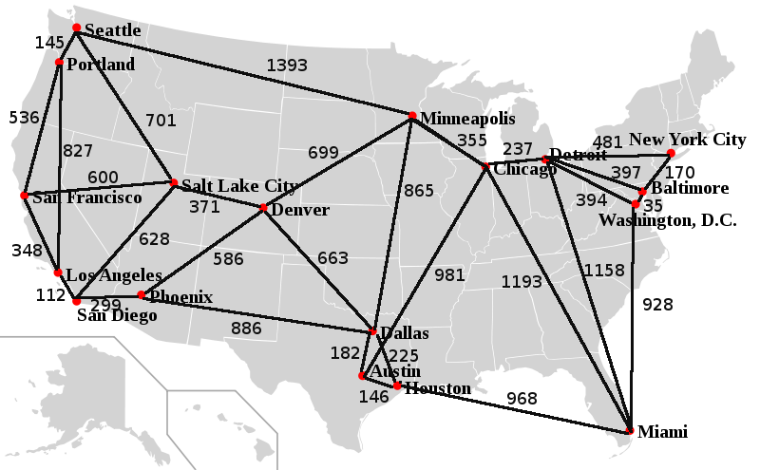

**START NODE:**  Seattle

**END NODE:** Miami

**STRAIGHT-LINE DISTANCE TO MIAMI (MI)**

|  |  |
| --- | --- |
| **Seattle** | 2735 |
| **Portland** | 2708 |
| **San Francisco** | 2594 |
| **Los Angeles** | 2338 |
| **San Diego** | 2271 |
| **Phoenix** | 1981 |
| **Salt Lake City** | 2090 |
| **Denver** | 1727 |
| **Dallas** | 1111 |

*GREEDY BEST-FIRST SEARCH:*

TOTAL COST = 1393 + 865 + 225 + 968 = **3451 miles**

*A* SEARCH:*

**TOTAL COST** = 701 + 371 + 663 + 225 + 968 = **2928 miles**

***A* search saves costs by 523 miles (3451 miles – 2928 miles).***